Pinwheels for Prevention Campaign™ 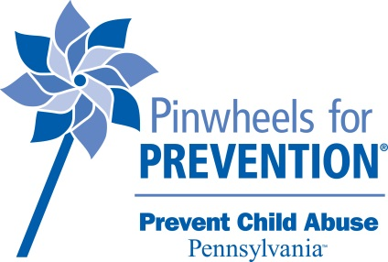

The Pinwheels for Prevention Campaign is the national platform of Prevent Child Abuse America that began in 2008 and has firmly established the pinwheel as the symbol of child abuse prevention. The pinwheel stands for the carefree childhood we want for all children and is a call to neighbors, community members and leaders to play a role in protecting and nurturing our youngest citizens. Our ultimate goal is for abuse and neglect to never occur and to share the message that Prevention IS Possible.

How to participate in the Pinwheels for Prevention Campaign:

The pinwheel can be used in a variety of creative ways and associated with the good work done by organizations as well as celebrating the lives of children. We only ask that you do not associate the pinwheel with cases of child abuse or child deaths as we aim to highlight the programs and services that are having a positive impact on children and families. Here are some ideas to get you started:
- Provide a pinwheel for each student to display outside their home so the prevention message can be seen throughout the community.
- Organize a fundraiser by collecting donations in exchange for a pinwheel that can then be planted in a “pinwheel garden” at your school or place of work.
- Host a pinwheel parade with every child waving a pinwheel.
- Sponsor a “Pajamas for Prevention” day at school or a dress-down day at work for donations to Prevent Child Abuse PA.
- Create a pinwheel bouquet as a way of acknowledging a person or organization for their efforts at keeping children safe.
- Incorporate pinwheels into the centerpieces at your next gala event.
- Support Prevent Child Abuse PA with your own prevention fundraiser. Some ideas include: Pizzas for Prevention, Paramedics for Prevention, Puppies and Purrs for Prevention, Pep Rally’s, Principals, Pastors, Police, Parents, Pennsylvanians for Prevention - you get the idea. Get creative, invite competition, and have fun!

For questions or for more information, contact Teresa Olsen at tolsen@paaap.org or 484-446-3033.

